This template provides formatting guidelines for authors to prepare the extended abstract. The length of the abstract should be at least 800 words but within 3 to 4 pages.

Extended abstract should comprise the following sections: Introduction, Methods, Findings,
Conclusion and References.

Font: Times New Roman, size 11, single line spacing for all justified contents.

TITLE

Author Name^{1*}, Author Name², Author Name³
[Full name of all authors, superscript 1, 2, 3 etc. denote affiliation]

¹Faculty of Applied Sciences, Universiti Teknologi Mara Cawangan Sarawak, Malaysia
²Faculty of Computer and Mathematical Sciences, Universiti Teknologi Mara, Malaysia
³School of Physics, Universiti Sains Malaysia, Penang

*Corresponding author: email address

Abstract
A concise, single paragraph abstract is required. The abstract should briefly state the purpose of the research, research methodology, the principal results, and the primary conclusions. Maximum 200 words. Keywords: Maximum 5

Introduction
State the background and objectives of the study, highlighting the importance or novelty of the research.

Methods
Experimental / Computational details / Research Methodology.
Please provide sufficient details of the procedures used. The use of known methods should be indicated by reference.

Findings
Results can be presented in the form of Table or Graph or Figure or the combination of these forms. The Table or Graph or Figure must be centered and numbered accordingly (For example: Figure 1, Table 1, Table 2). Table heading must be placed on the top of the Table while the definition of Figure or Graph must be placed under the image.

Discussions should be brief, clear, and concise.

Table 1: Validation data from calibration curves of compounds (4) and (5)

Compounds | R2 | Detection Limit (mg/mL) | Quantitation Limit (mg/mL) | Purity (%)
p-coumaric acid (4) | 0.9924 | 1.10 × 10−7 | 3.32 × 10−7 | 99
4-methoxycinnamic acid (5) | 0.9835 | 5.48 × 10−7 | 1.66 × 10−7 | 96

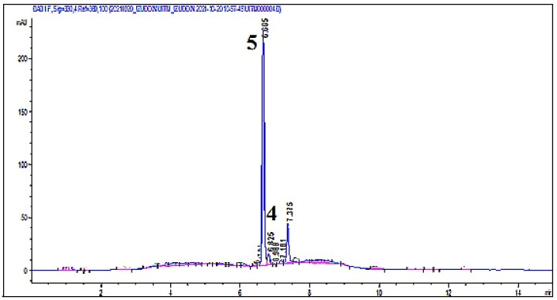

Figure 1: HPLC chromatogram of cold maceration ethanol extract (BBER)

Conclusion
Please do not use numbering. Incorporating the most important findings as well as future work.

Acknowledgements
Word of thanks for grants, equipment, samples, etc. should be expressed in the acknowledgment section.

References

Total number of references must not exceed 10.

[1] Y. H. R. Chang, T. L. Yoon and T. L. Lim (2016). Ab initio computations of the linear and nonlinear optical properties of stable compounds in Al-In-N system. Current Applied Physics, 16, 1277-1283.

[2] Y. H. R. Chang, T. L. Yoon, T. L. Lim, P. W. Koh and M. H. Tuh (2019). Frequency dependent linear and nonlinear optical properties of compositionally tuned inorganic CsSnX (X = Br, I) composites. Journal of Alloys and Compounds, 779, 497-504.

